List and Dictionary

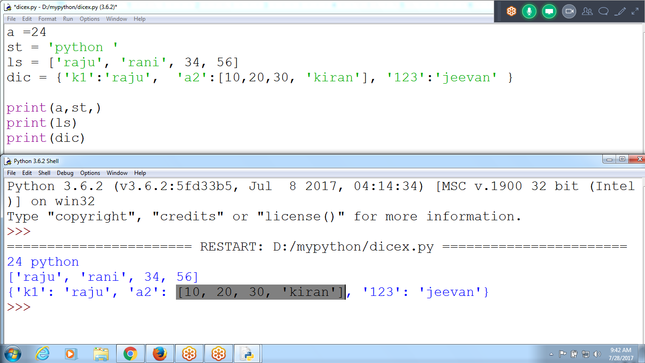

a =24

st = 'python '

ls = ['raju', 'rani', 34, 56]

dic = {'k1':'raju', 'a2':[10,20,30, 'kiran'], '123':'jeevan' }

print(a,st,)

print(ls)

print(dic)

Using Dictionary and List Methods

Checking User id and password

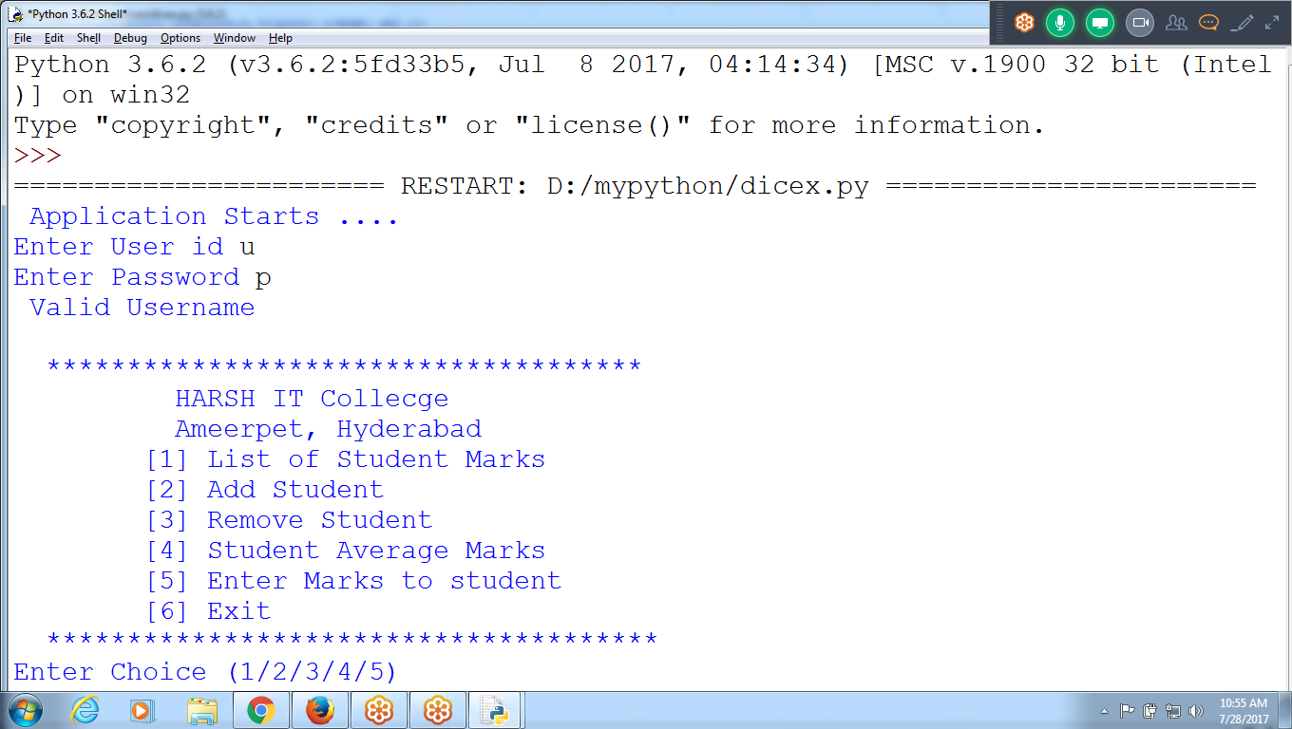

Select Choice

Ch 1 : List of Student Marks

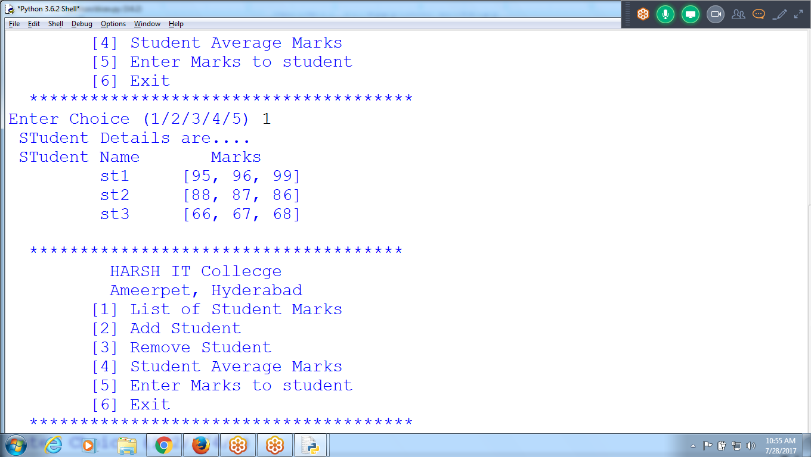

Ch = 2 for Adding student :: st10

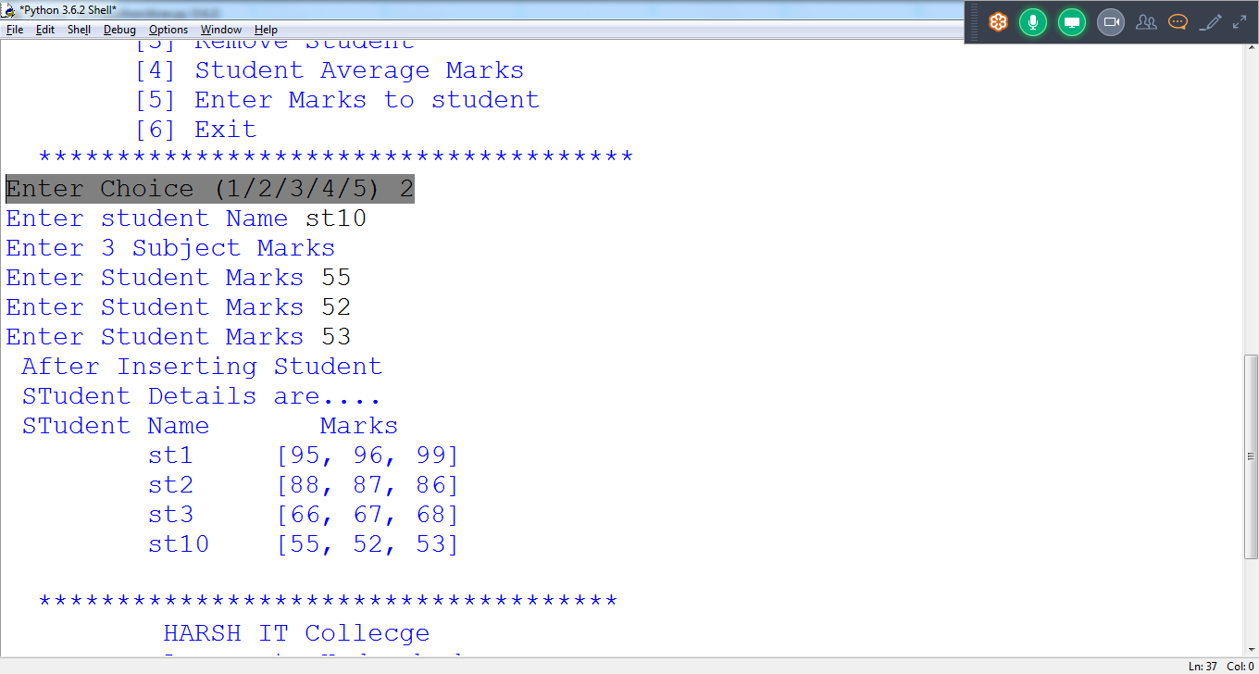

ch=3 Remove Student :: st10

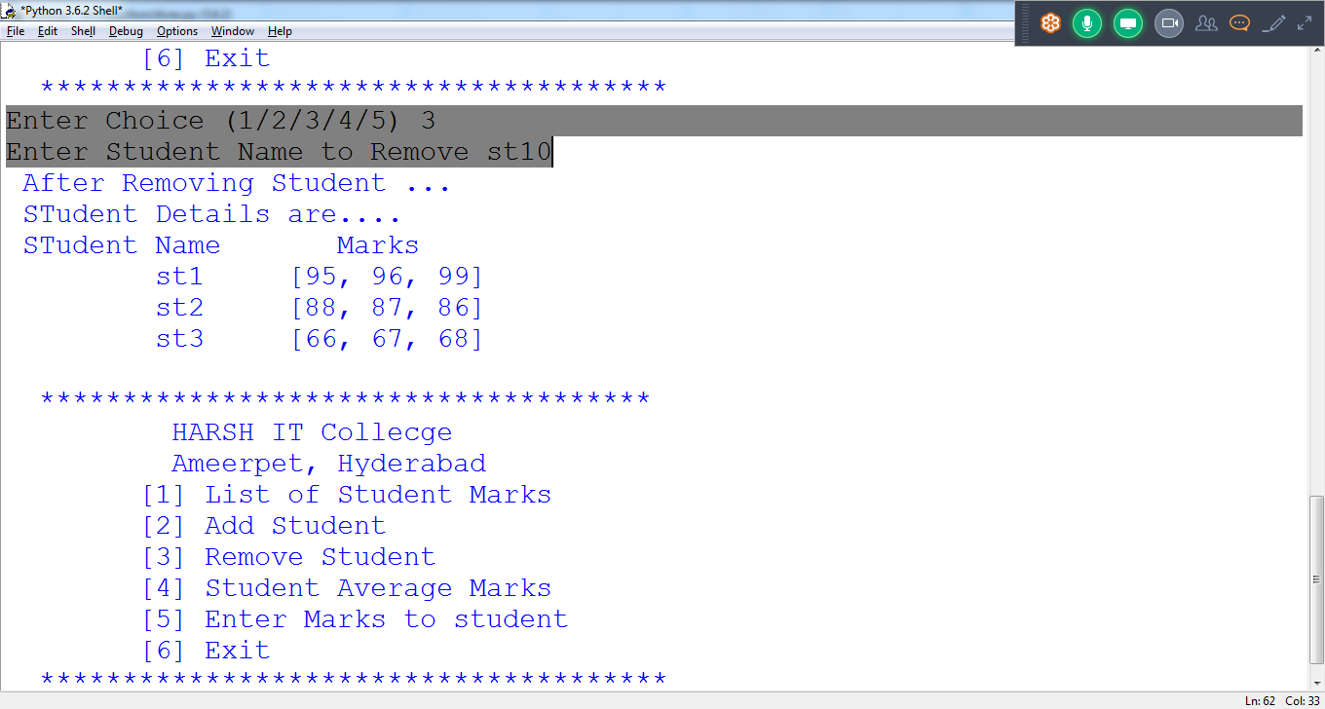

Ch = 4 :: student Average Marks

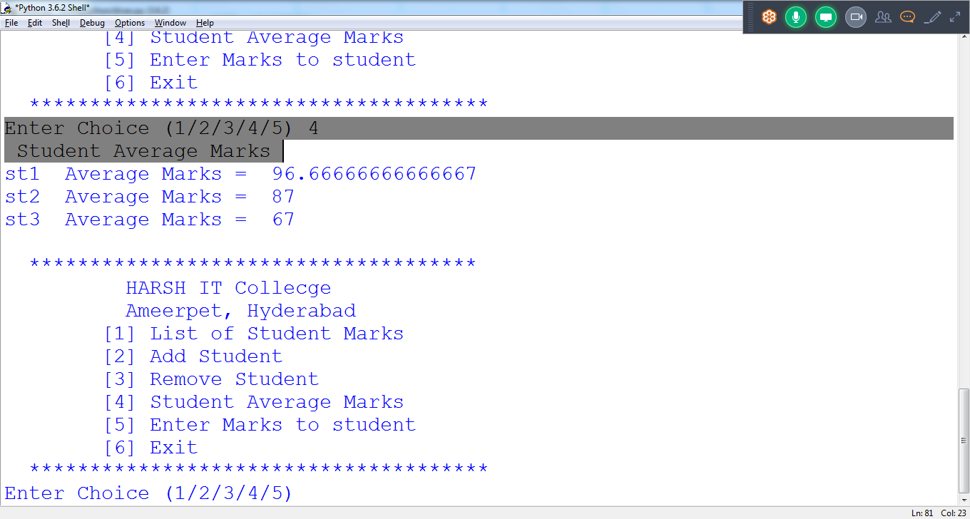

Ch == 5 (Enter new marks to sudent )

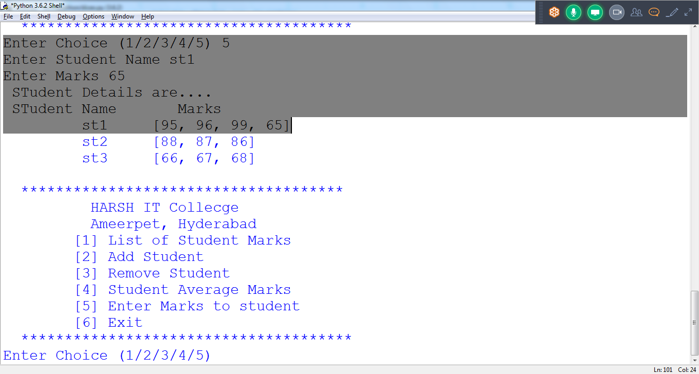

Ch = 6/7/8/ “ Exit “ :: Close the program

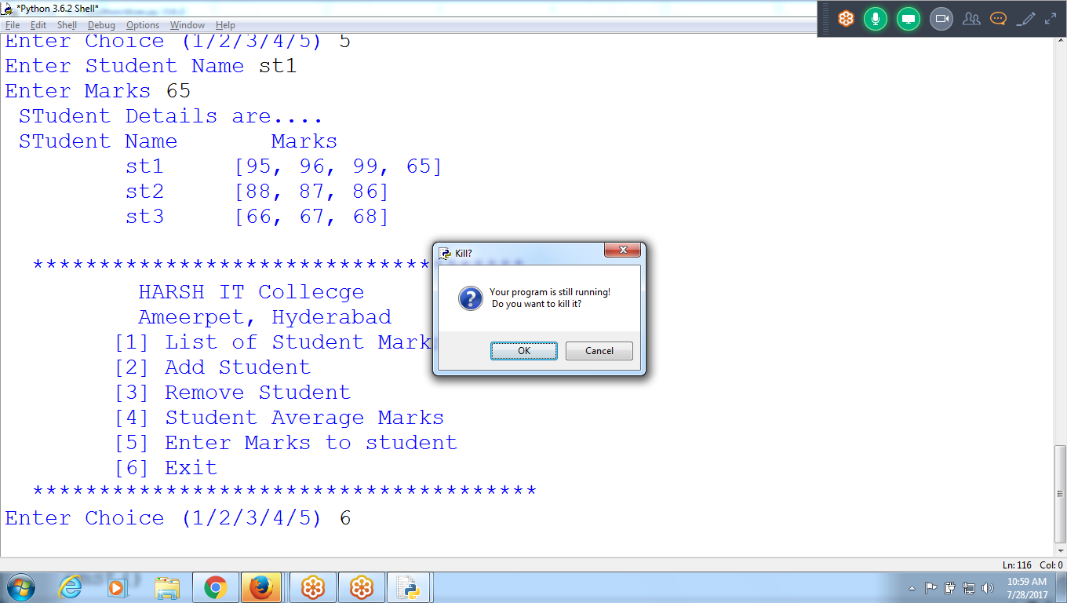

#import statistics

**from statistics import mean as m**

userdic = {'u':'p', 'user2':'pwd2', 'user3':'pwd3'}

studic = {'st1':[95,96,99], 'st2':[88,87,86], 'st3':[66,67,68]}

**def lsm(): # Displaying Student Detail Marks**

#print(studdic)

print(' STudent Details are.... ')

print(' STudent Name \t Marks ')

for st in studic:

print('\t', st, '\t', studic[st])

**def ast(): # Add student with List of 3 subject marks**

lsmar=[]

stname = input('Enter student Name ')

print('Enter 3 Subject Marks ')

for i in range(1,4):

stmarks = int(input('Enter Student Marks '))

lsmar.append(stmarks)

studic[stname] = lsmar

print(' After Inserting Student ')

lsm()

**def rst(): # Remove Student**

stname = input('Enter Student Name to Remove ')

if stname in studic:

del studic[stname]

print(' After Removing Student ... ')

lsm()

**def sam(): # Student Average marks**

print(' Student Average Marks ')

for st in studic:

mls = studic[st]

#avgm = statstics.mean(mls)

avgm = m(mls)

print(st, ' Average Marks = ', avgm)

**def emst(): #Enter Marks to Student**

stname = input('Enter Student Name ') #st2

mar = int(input('Enter Marks ')) #85

if stname in studic:

studic[stname].append(mar)

lsm()

else:

print(stname, ' Student Not Exist ')

**def f1():**

print('''

*************************************

HARSH IT Collecge

Ameerpet, Hyderabad

[1] List of Student Marks

[2] Add Student

[3] Remove Student

[4] Student Average Marks

[5] Enter Marks to student

[6] Exit

************************************** ''')

ch = input('Enter Choice (1/2/3/4/5) ')

if(ch == '1'):

lsm()

elif(ch == '2'):

ast()

elif(ch == '3'):

rst()

elif(ch == '4'):

sam()

elif(ch == '5'):

emst()

else:

exit()

**print(' Application Starts .... ')**

uid = input('Enter User id ')

pwd = input('Enter Password ')

if uid in userdic:

if pwd == userdic[uid]:

print(' Valid Username ')

**while True:**

**f1()**

else:

print(' Wrong Password ')

else:

print(' Invalid User ')